**Digital Forensics: Wasting Time on the Company’s Dime**

**A Project Report presented to the**

**Department of Computer Science and Engineering,**

**The NorthCap University**

**Submitted by:**

**Rohit Sehrawat**

**Swapnil Sunil Chaudhari**

**Riyansh**

**Roll no.:**

**20CSU335**

**20CSU343**

**20CSU310**

**Supervised by:**

**Dr. Prachi**

**ABSTRACT**

This report aims to oversee a digital investigation of pc of an employee, Lewis Capstone who works as a tech in the IT department of Lion’s Legal, a large law firm in town. Management has Lewis’s hard drive imaged and sent for analysis because management notices that Lewis is not as productive as his co-workers in the same department. Lewis’s attendance is not an issue; in fact, he is often in the office long after his co-workers have gone home for the day. Management suspects that Lewis is spending his work time performing unrelated activities. Since Lewis’s performance is substandard, his extended work hours are suspect as well. Before any accusations are made, it is decided that the first course of action should be to check his computer for unauthorized use.

Our report aims to oversee and examine the device of Mr Lewis and to provide a comprehensive result for this case which proves if he is wasting company resources or just being suspected of wrong things.

**INTRODUCTION**

Let's start by introducing both sides of this case:

* Lion’s Legal is a large law firm in town. Lion’s Legal has a strict policy prohibiting Internet use for anything but company business during work hours.
* Lewis Capstone works as a tech in the IT department of Lion’s Legal, a large law firm in town. During a quarterly employee review, management notices that Lewis is not as productive as his co-workers in the same department. Lewis’s performance is substandard, his extended work hours are suspect as well.

Now Lion believes that Mr Lewis is wasting his work hours playing games, watching movies, and using the company resources to pass time and to get paid doing subpar work. Also, he is staying late for work and is suspected of wasting that time too to get extra pay just by stay late for work in overtime.

Our team is part Legal’ forensic department and charged with task of examining Lewis Capstone’s computer’s image to find the required evidence proving either the suspicion true or his innocence in this case.

I am the lead investigator of our team, and we will analyse the image of Mr. Lewis Capstone’s hard drive and then will be using forensic tools such as Postbox, USBDeview, Event Viewer ,FTK Imager And Autopsy to dig deeper and comprehensively investigate it getting the suspicions clear or getting justice to the Lion Legal.

**INDEX**

|  |  |  |  |
| --- | --- | --- | --- |
| **CONTENTS** | | | |
| **S.No.** | **Details** | **Page No.** | |
| 1 | Forensic tools used in the project |  | |
| 2 | Explanations of the tools used in the project |  |
| 3 | General Overview of The Investigation |  |
| 4 | Short Overview of The Image’s Contents |  |
| 5 | Detailed Breakdown of The Cyber Crime |  |
| 6 | Evidence List |  |
| 7 | Challenges |  |
| 8 | References |  |

**BODY**

**Forensics tools used in the project**

* Postbox
* USBDeview
* Event Viewer
* FTK Imager
* Autopsy

**Explanations of the things used in the project**

1. **Postbox**

Postbox is a desktop email client, news client and feed reader for Windows and macOS. Written and sold by Postbox, Inc., it was launched at the TechCrunch 50 conference in 2008. Postbox was founded and staffed by several former developers from Mozilla



1. **USBDeview**

USBDeview is a freeware utility tool developed by NirSoft, a website operated by one man. It gives you information about all the USB devices you use—not only the ones that you’re currently using, but also all those you’ve connected to your computer at some point in the past. This is a lightweight program that is fully capable of displaying extended information related to USB devices.



1. **Event Viewer**

Event Viewer is a component of Microsoft's Windows NT operating system that lets administrators and users view the event logs on a local or remote machine.

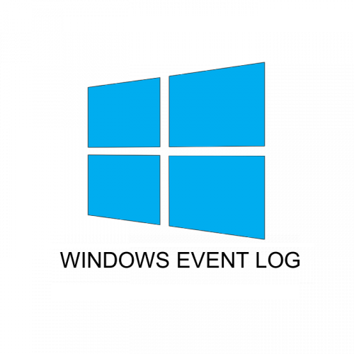

1. **FTK Imager**

Forensic Toolkit, or FTK, is a [computer forensics](https://en.wikipedia.org/wiki/Computer_forensics) software made by [AccessData](https://en.wikipedia.org/w/index.php?title=AccessData&action=edit&redlink=1). It scans a hard drive looking for various information.[[1]](https://en.wikipedia.org/wiki/Forensic_Toolkit#cite_note-wired-1)

It can, for example, potentially locate deleted emails[[2]](https://en.wikipedia.org/wiki/Forensic_Toolkit#cite_note-Dixon-2) and scan a disk for text strings to use them as a [password dictionary](https://en.wikipedia.org/wiki/Password_dictionary) to crack encryption.[[3]](https://en.wikipedia.org/wiki/Forensic_Toolkit#cite_note-Casey-3)

FTK is also associated with a standalone [disk imaging](https://en.wikipedia.org/wiki/Disk_imaging#Hard_drive_imaging) program called FTK Imager. This tool saves an image of a hard disk in one file or in segments that may be later on reconstructed. It calculates [MD5](https://en.wikipedia.org/wiki/MD5) and [SHA1](https://en.wikipedia.org/wiki/SHA-1) [hash values](https://en.wikipedia.org/wiki/Hash_values) and can verify the integrity of the data imaged is consistent with the created forensic image.

The forensic image can be saved in several formats, including DD/raw, E01, and AD1. (3)



1. **Autopsy**

Autopsy is computer software that makes it simpler to deploy many of the open source programs and plugins used in The Sleuth Kit. The graphical user interface displays the results from the forensic search of the underlying volume making it easier for investigators to flag pertinent sections of data.



**General Overview for The Investigation**

First, our private company filled out the Chain Of Custody form for the computers of all the parties involved i.e. Lewis Capstone

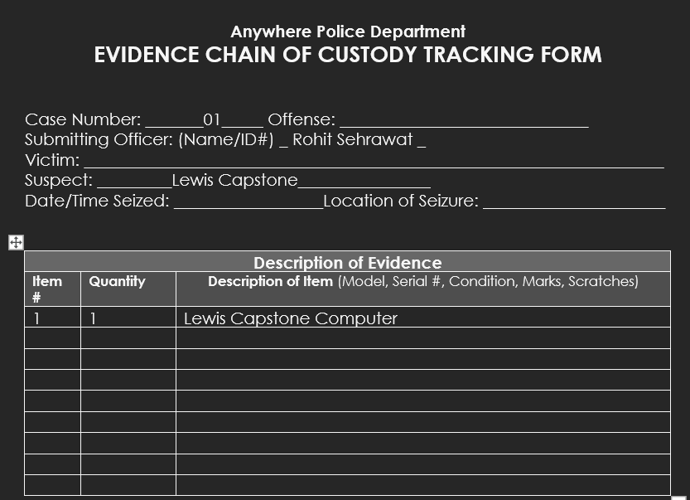

Then we start to analyze Lewis Capstone Computer. The Steps taken are as follows:

1. Initiate write blocker
2. Insert a pen drive into the computer with FTK Imager installed
3. Open FTK Imager

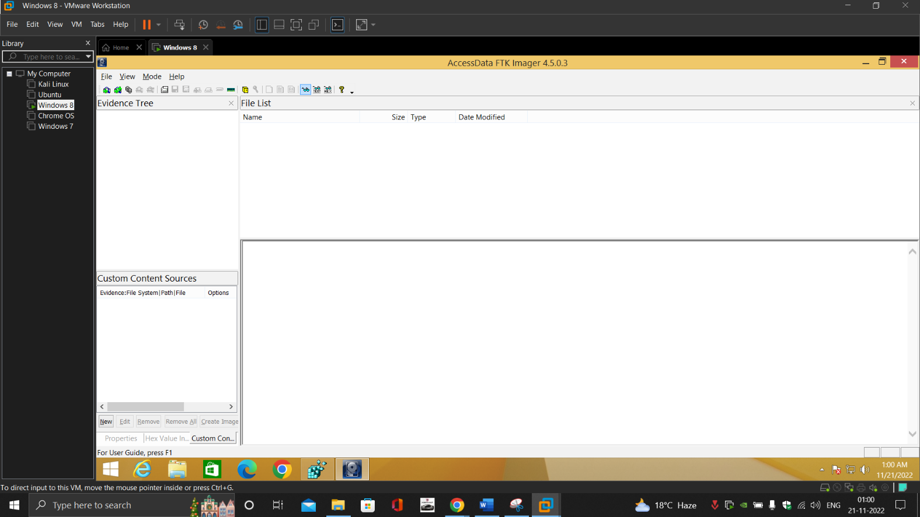

1. Create an EO1 Forensic Image and save it on the pen drive

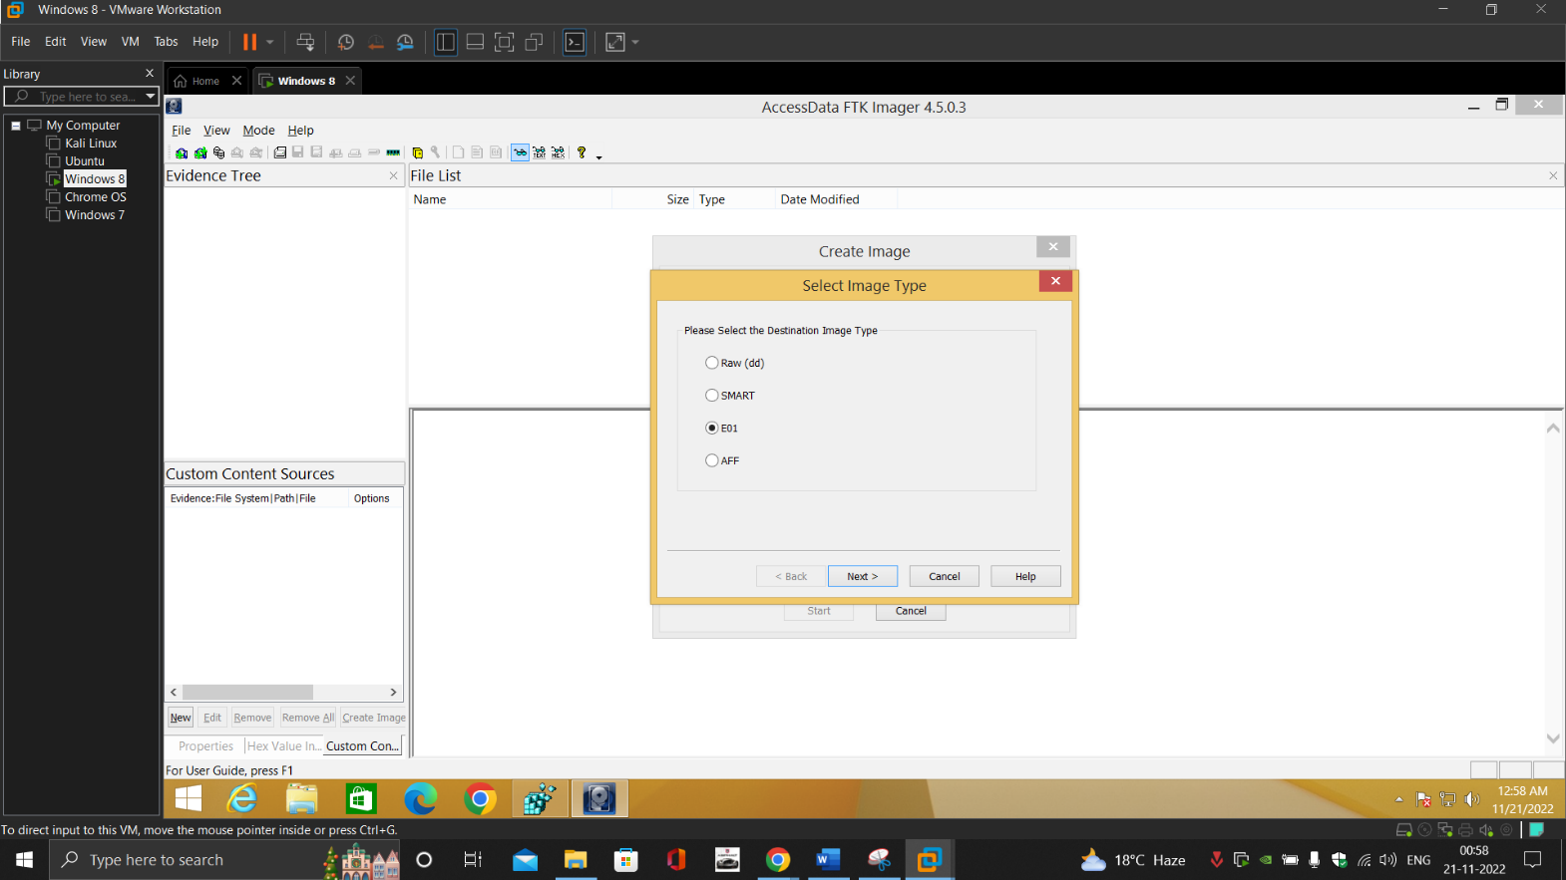

1. We then checked for the last login times

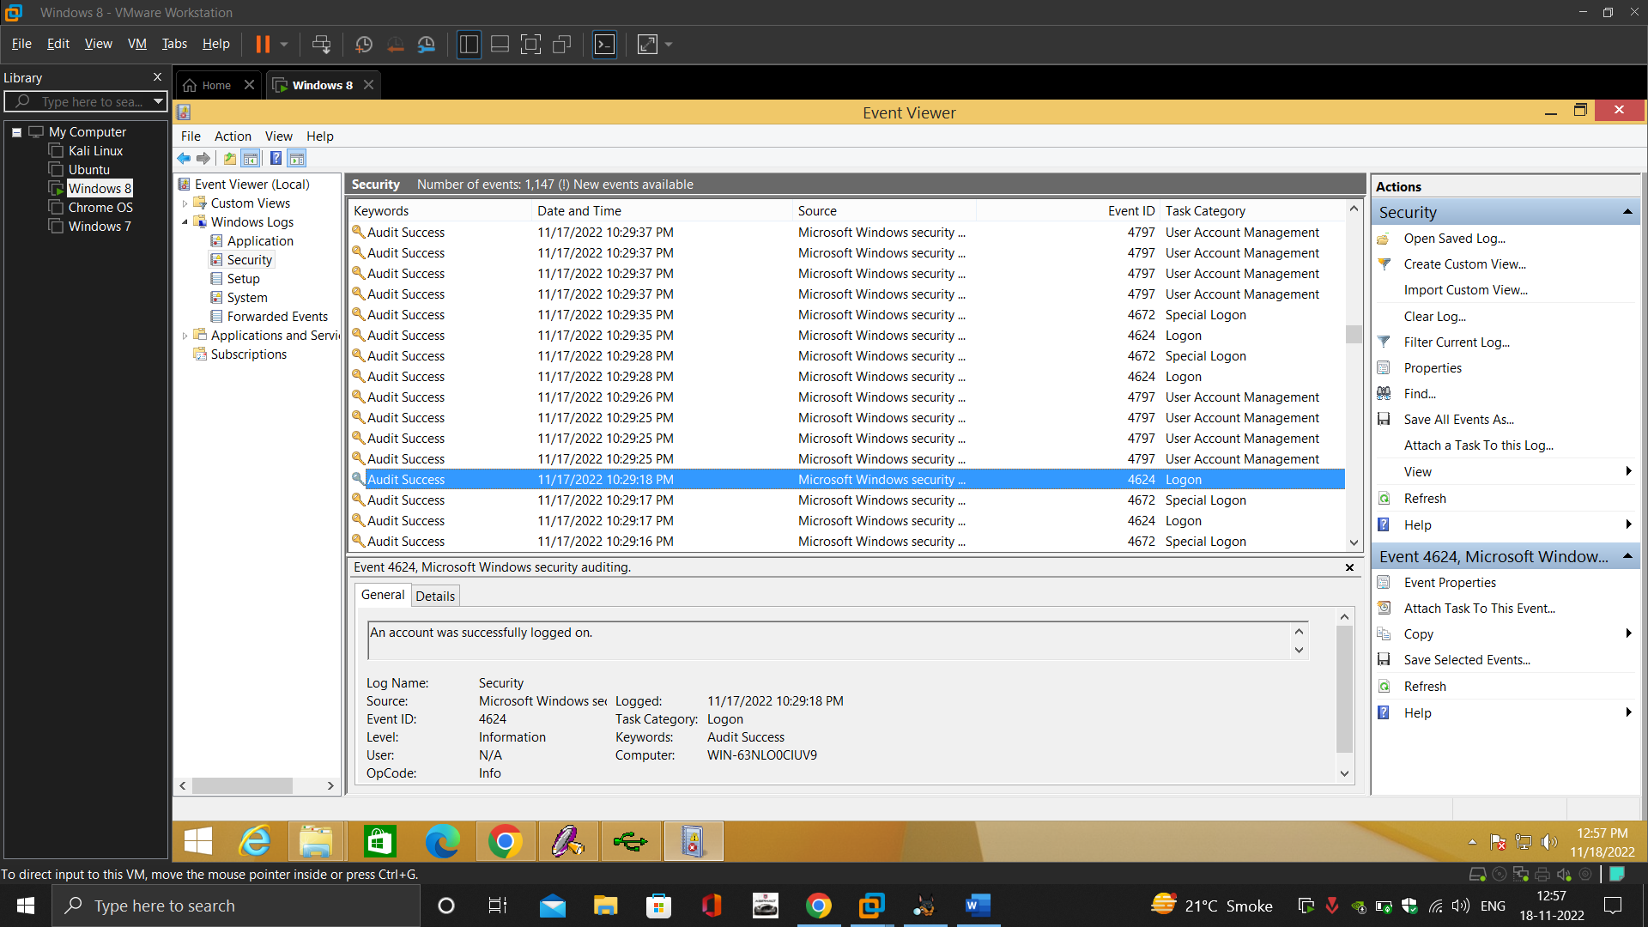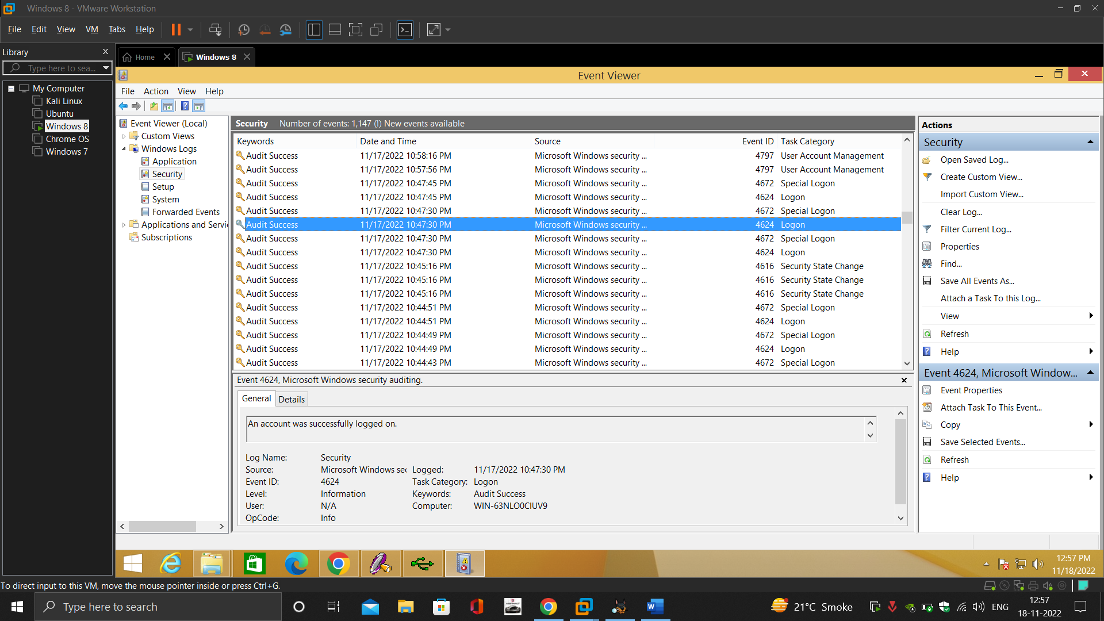

1. No of users in the PC

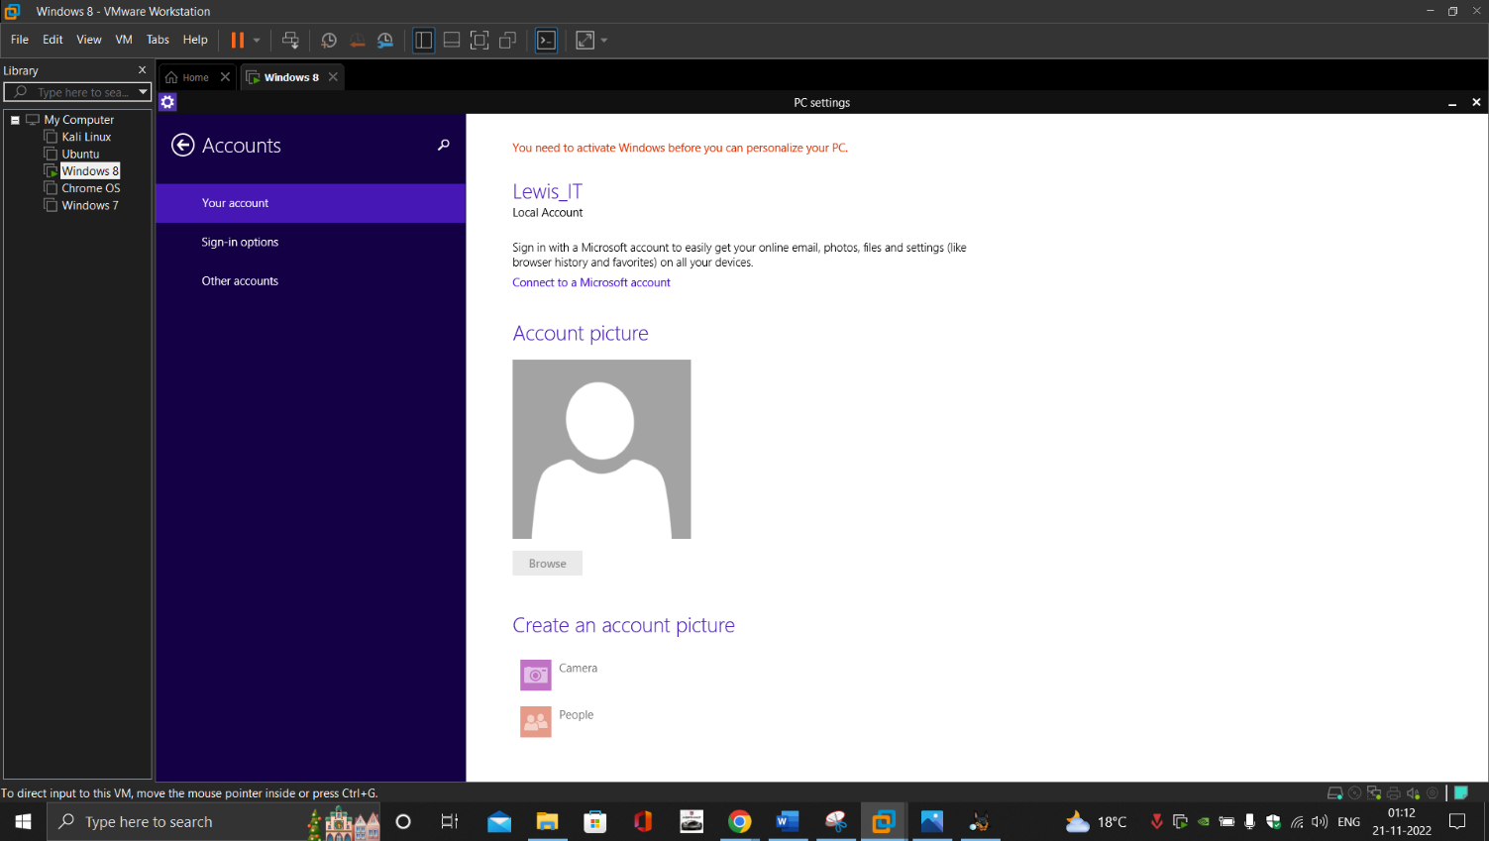

* Default
* Guest
* PLAYerUnKnown
* Public

1. We then checked for any external drives that were connected to the computer

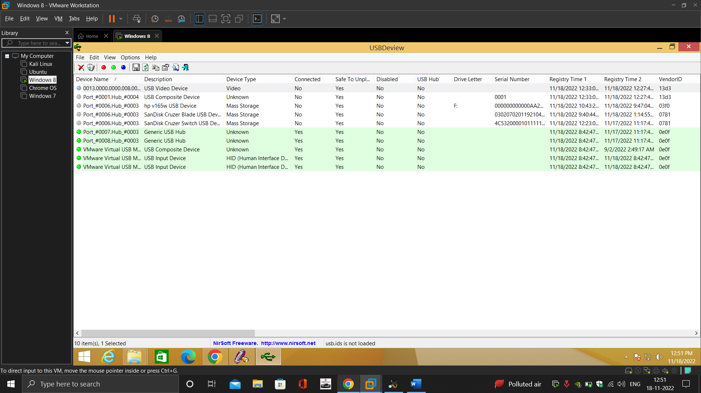

1. Internet history

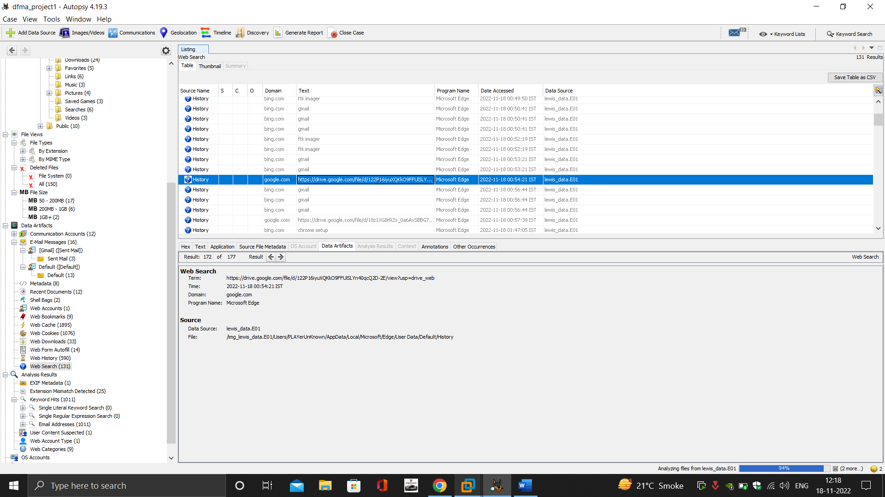

1. Downloads

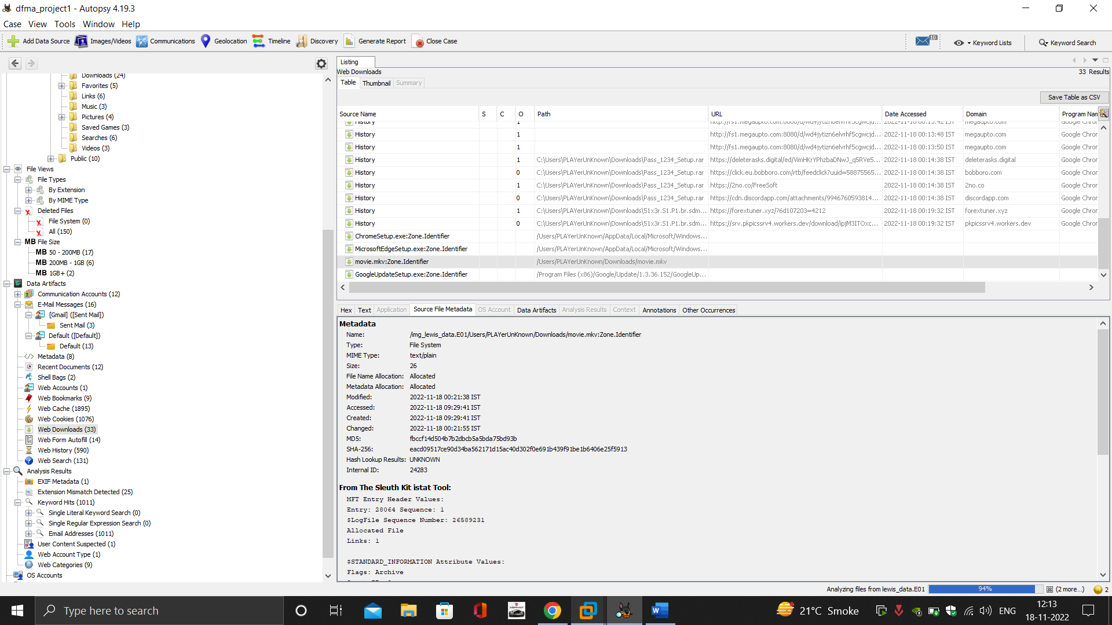

1. Bookmarks

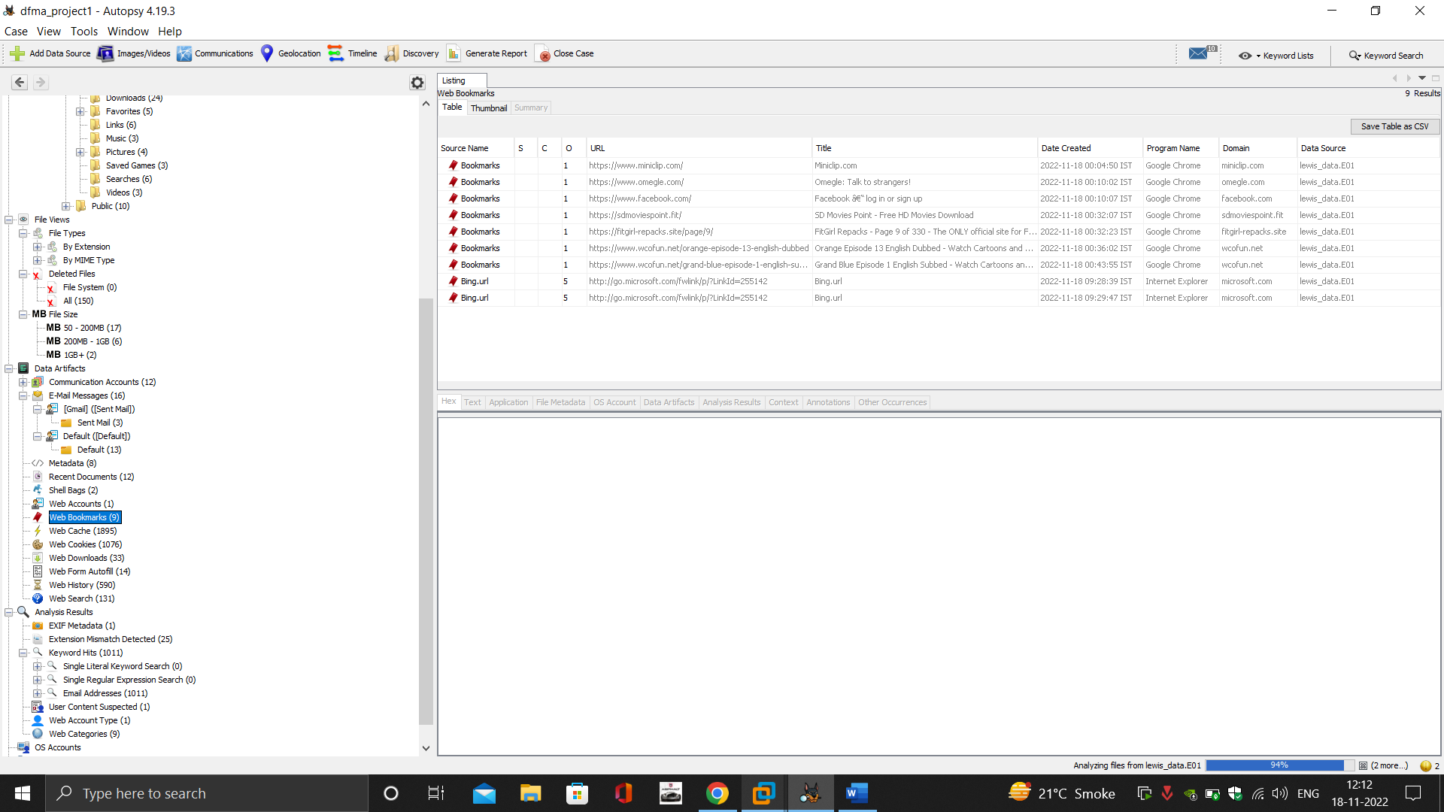

1. Personal ID of google and email logged in pc

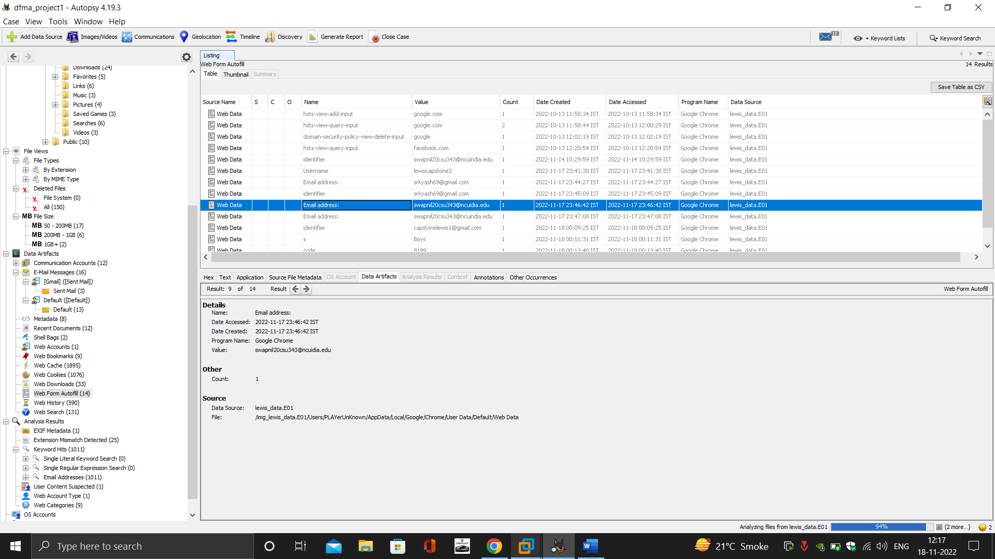

1. Inbox details

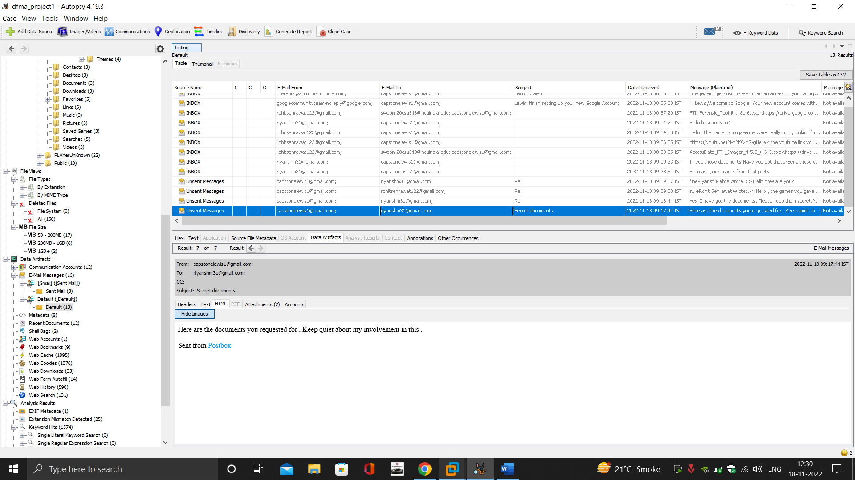

**Short Overview of the Image’s Contents:**

* Lewis’ Computer had a lot of company data on the desktop, and it wasn't secured by any means making it more likely to be in danger. The search history showed that he visited some pirated movies sites, online games sites. He also had bookmarked his favourite gaming and movies sites which he visited frequently. Also, he had logged in the pc with his personal email which is violation of company policy. With his personal email and accounts, he frequently visited social media sites like Facebook and interactive sites like Omeagle repeatedly. Forensics showed that he visited these sites for a very long duration at times and not just for checking updates.
* Also, there was evidence that he used a personal usb drive to send data to that drive which he downloaded from unauthenticated sites which are not allowed by company policies.
* Now coming to his emails which he was primarily using his personal account to chat with his friends and family. He used to chat with his friends on email and sent personal data prohibited by company policy.
* A suspicious person’s email showed that Lewis also shared company employees’ details to him breaking a ton of ethical and professional standards and laws.

**Detailed Breakdown of image contents and proof collection:**

First, we started with the accounts that were logged in the authorized pc of Lewis Capstone and found that he was using his personal account named Player Unknown, which clearly violated the guidelines provided by the company.

We found that he had stayed late in office till late nights showing that he was using his pc either to work or waste company resources, which we later found out to be a case of wasting company resources. So, we found out that he would login to his pc till late hours with his personal account to enjoy and not focus on his work.

Then we checked for external devices which were once connected to his devices, and we found that he had used a personal usb to send downloaded movies to that drive and use it for personal use. Which also violates the company guidelines.

Now we came to check his internet browsing habits and see what sites he frequented. In the browser data we found a lot of browsing data of certain social media, interaction, pirated movies, and online gaming sites. Few examples of these sites are as follows sdmoviespoint, Omeagle, Facebook, miniclip, myflixer.pw, wcofun.net, etc. After checking what time these sites were visited, we found that he would stay on the sites for a long duration and would frequently come back to the sites suggesting that whenever someone came near him he would close the tab and go back as soon as he felt safe. We also checked his bookmarked sites and found that after logging in to his personal gmail he had bookmarked the gaming and pirated movies sites for his easy. This all had already been a lot of red flags for Mr Lewis. After all this we found out that he had also frequently downloaded games and movies from sites and the download section had a lot of evidence to support that.

Till now we can conclude that he would log in to the pc with his personal account and would waste all his time on movies and gaming sites, violating as many company policies as possible and after downloading from these sites he would share that in his usb and use it somewhere else too.

Then we came to his emails for which he used postbox and found that he was using his personal account on postbox to chat with his friends and family. He would often have conversations with them during work hours and would send and receive links to gaming sites from his friends. We also found some of his images that his friend sent to him via email.

At this point we already have everything we need to prove that Mr Lewis Capstone had been wasting company time for his personal enjoyment and had been wasting resources.

But then we found something even more interesting from his emails showing that he had also sold some data of his office colleagues and company building plans to someone shady for money.

After some thorough investigation we were able to recover one file and one image that he had sent to that shady person for money or for some unknown benefits,

The document contained details of company employees along with their personal details related to bank accounts and home addresses and their phone numbers. The image contained blueprints for the company building that he worked for.

He talked about this data with someone on mail and we were able to gather all this revealing his bad intentions.

**Evidence List**

1. Image of hard drive

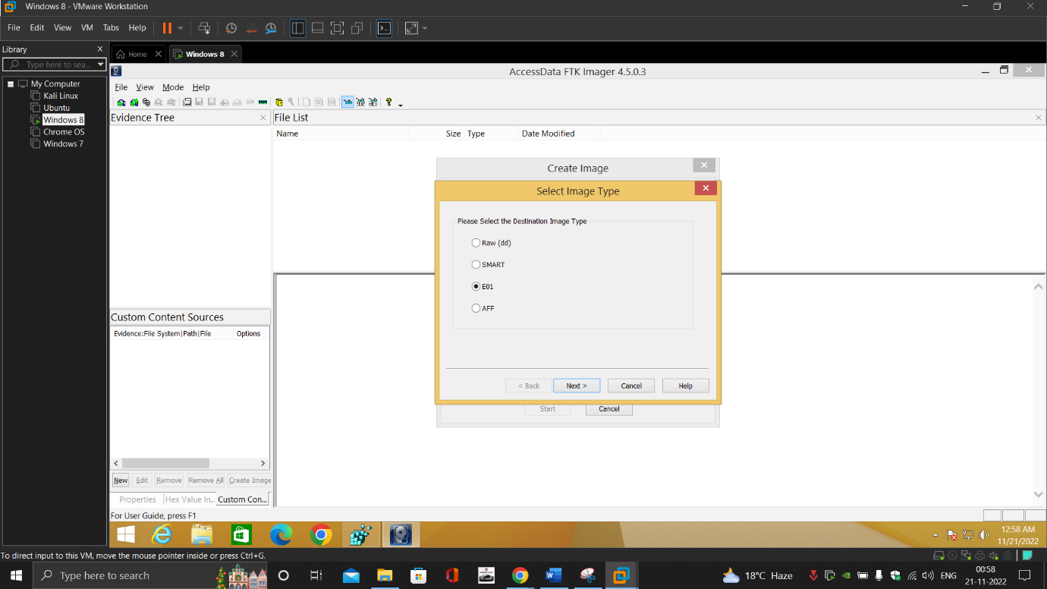

1. User accounts in PC

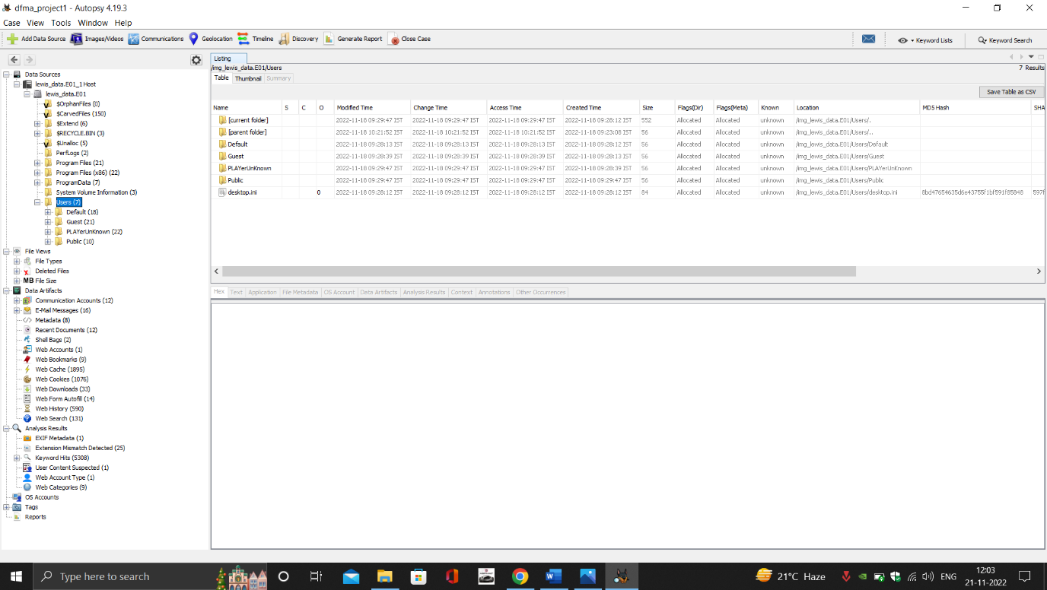

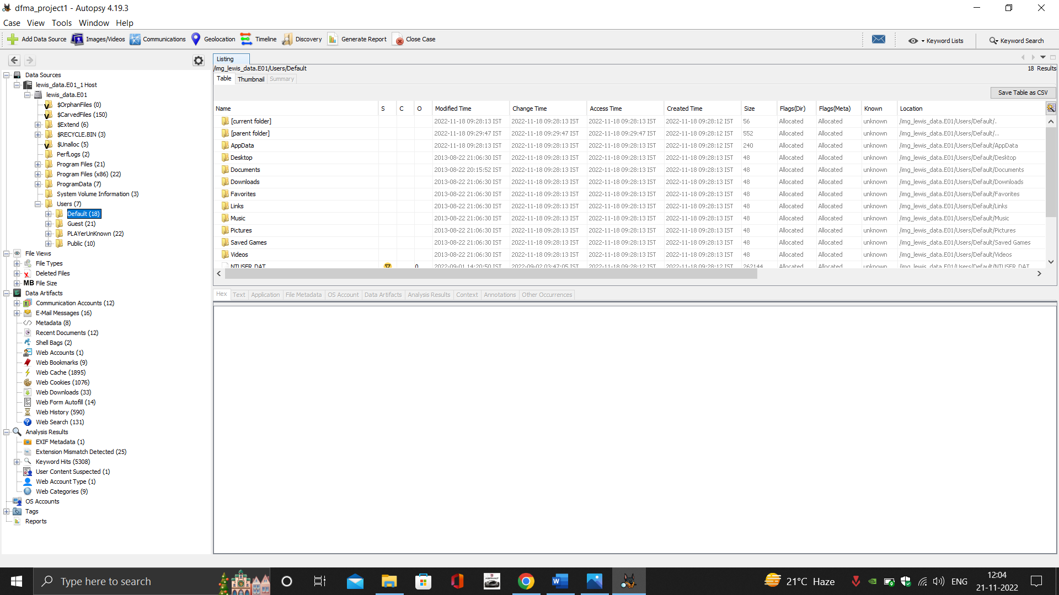

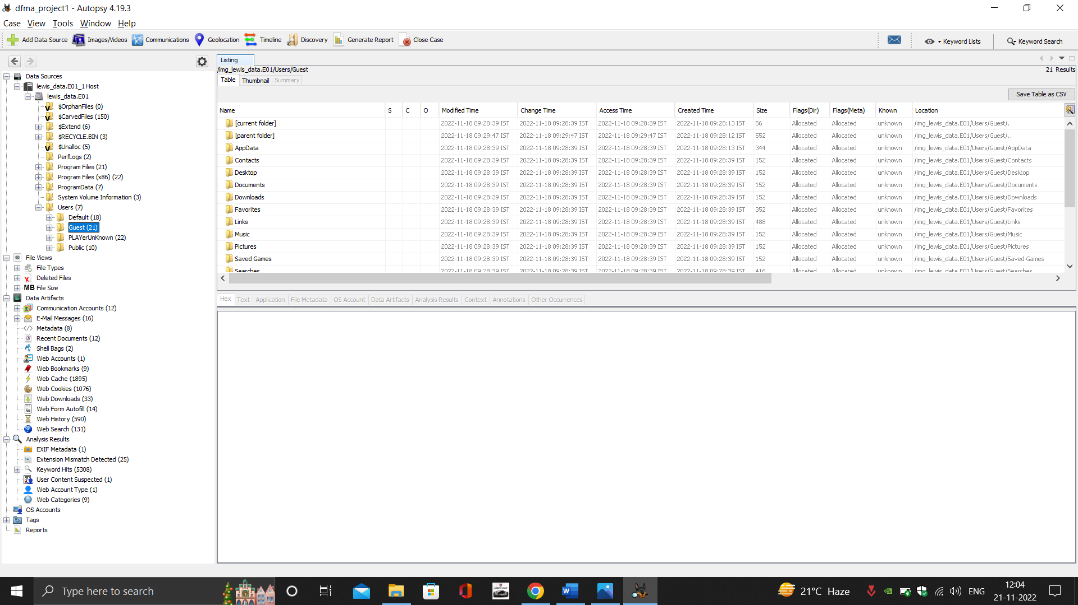

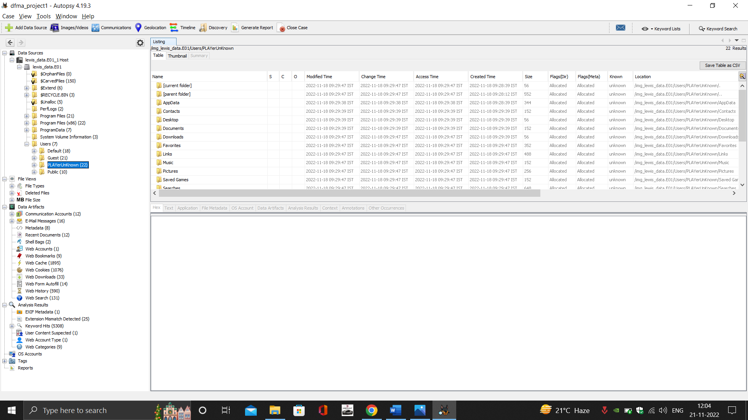

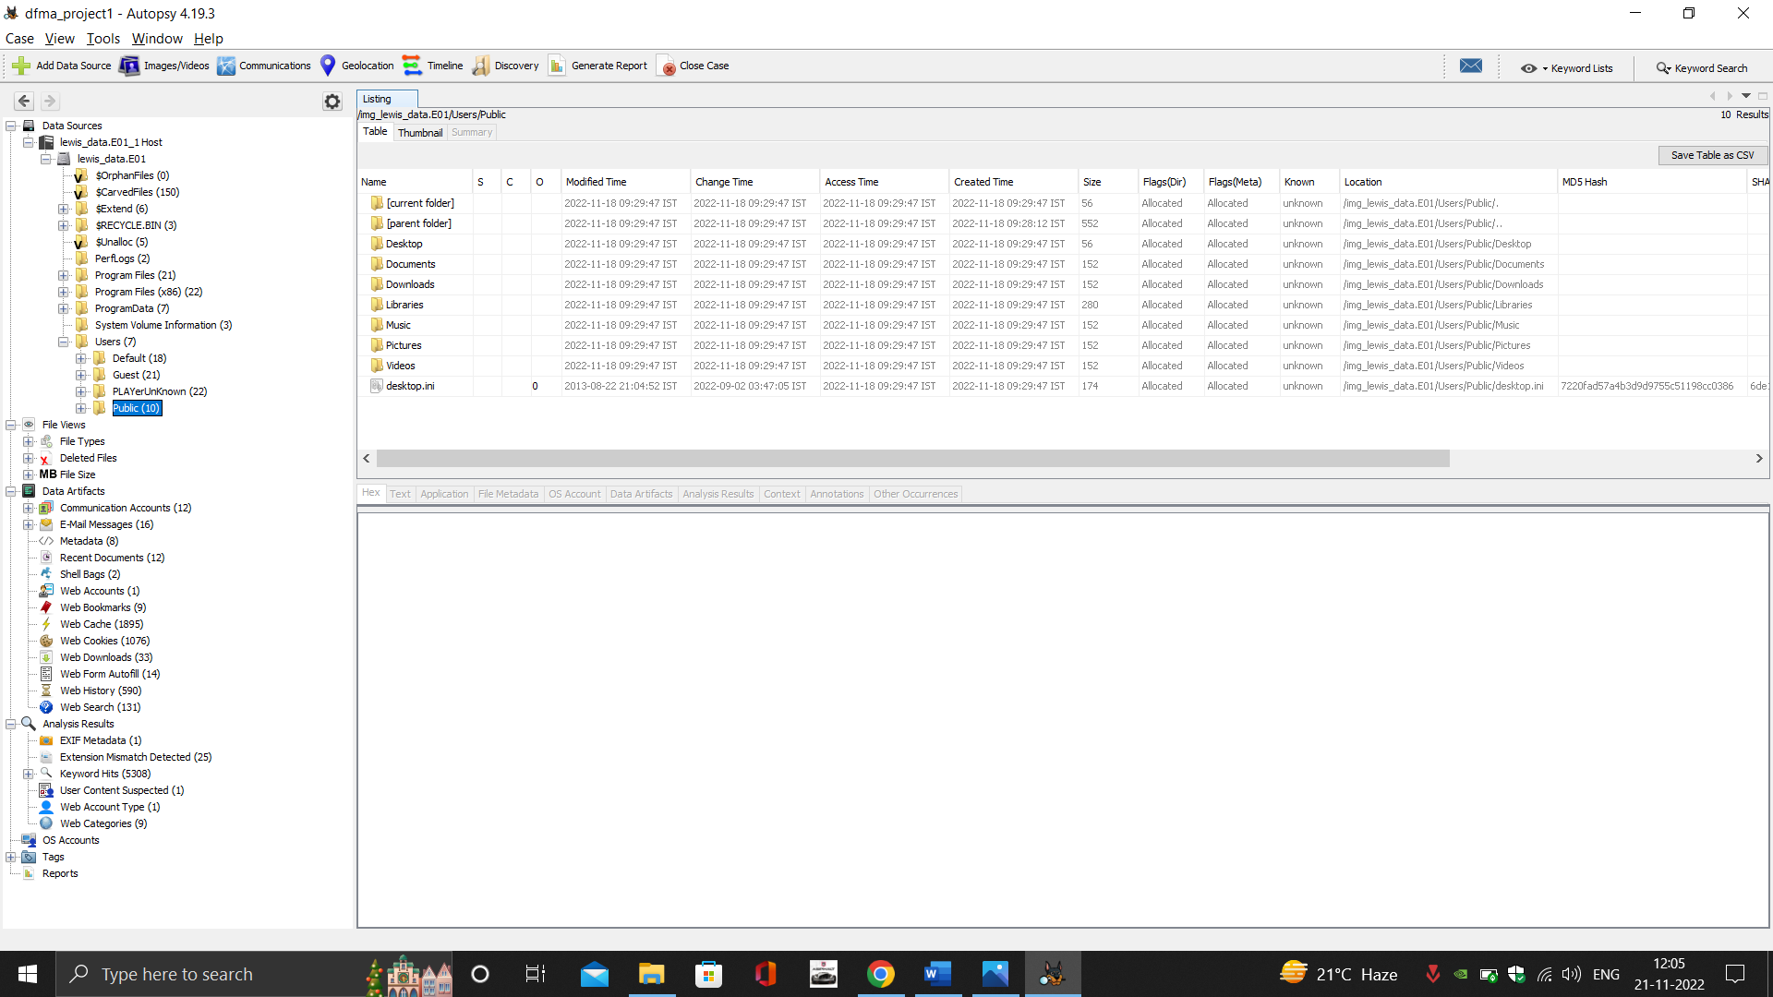

1. Connected external devices



1. Browser contents:

* History

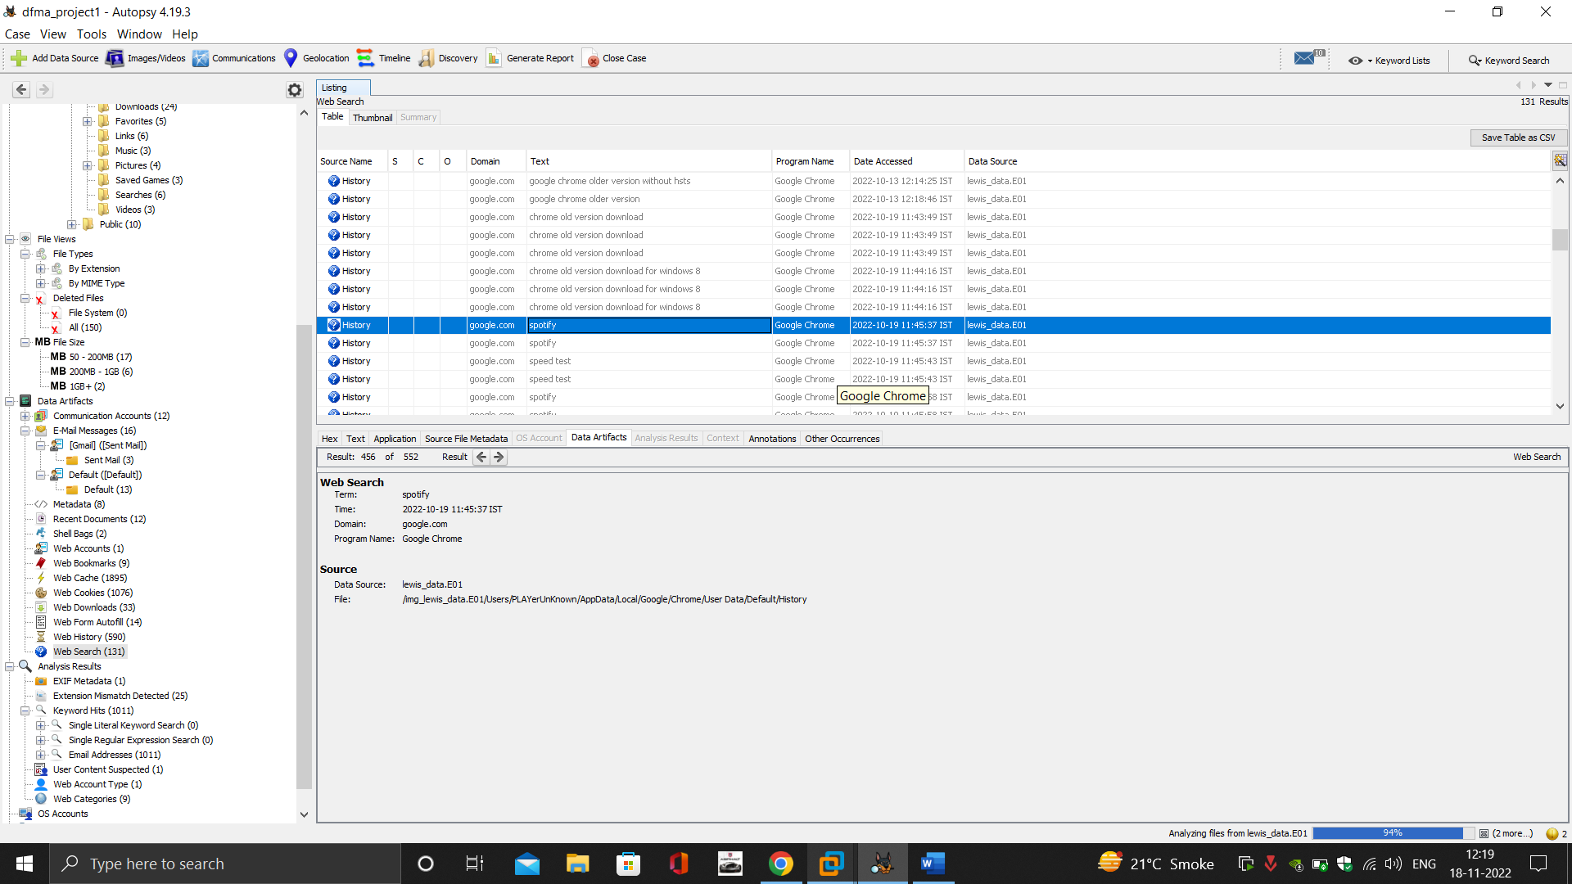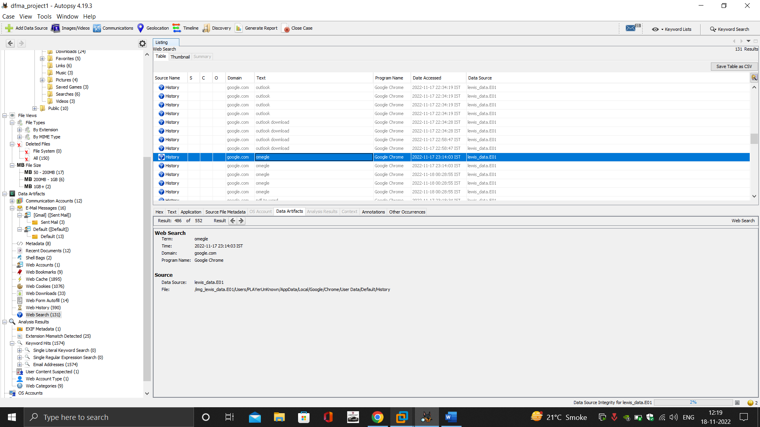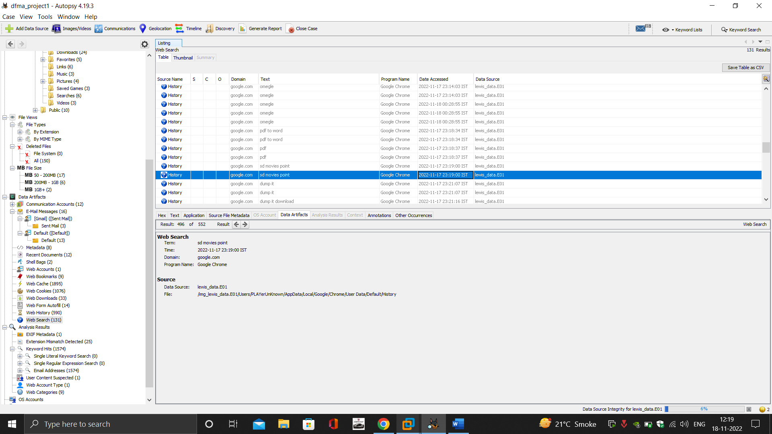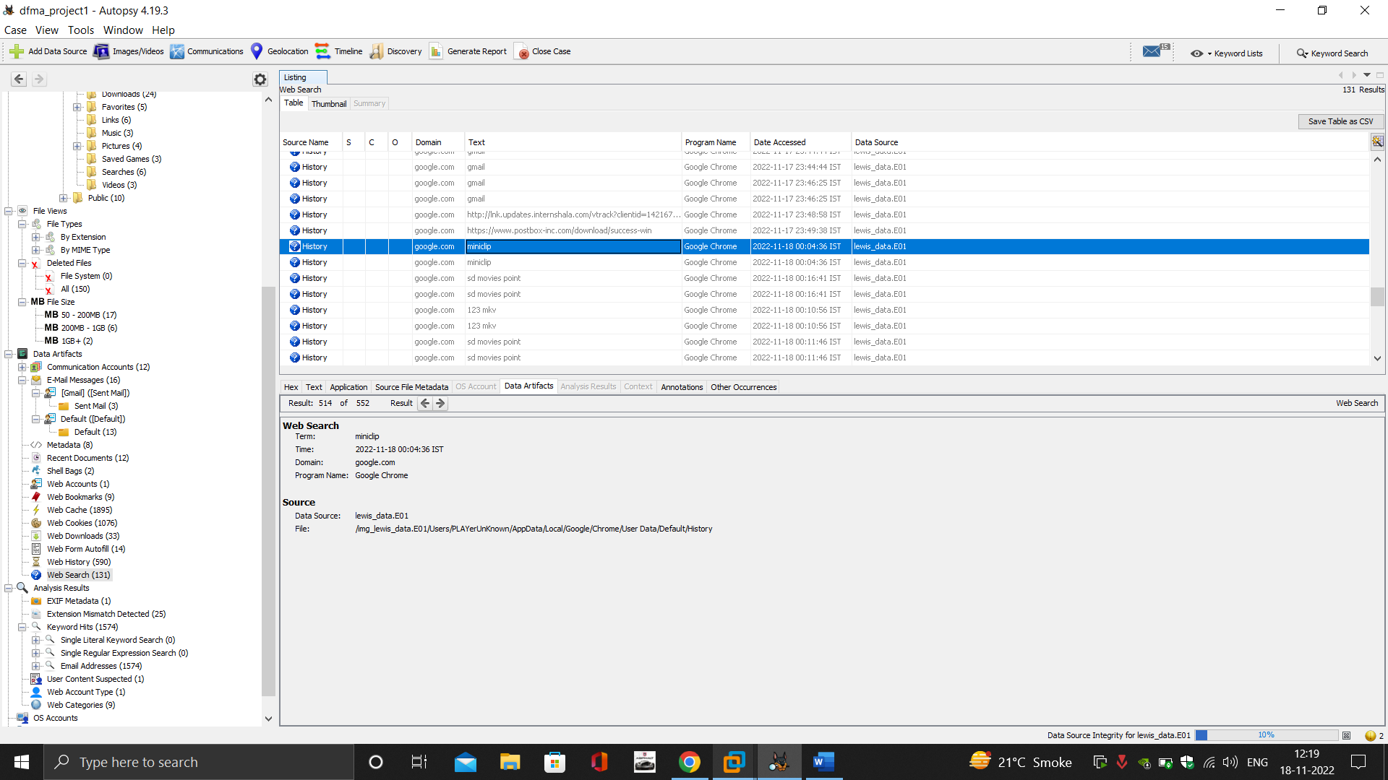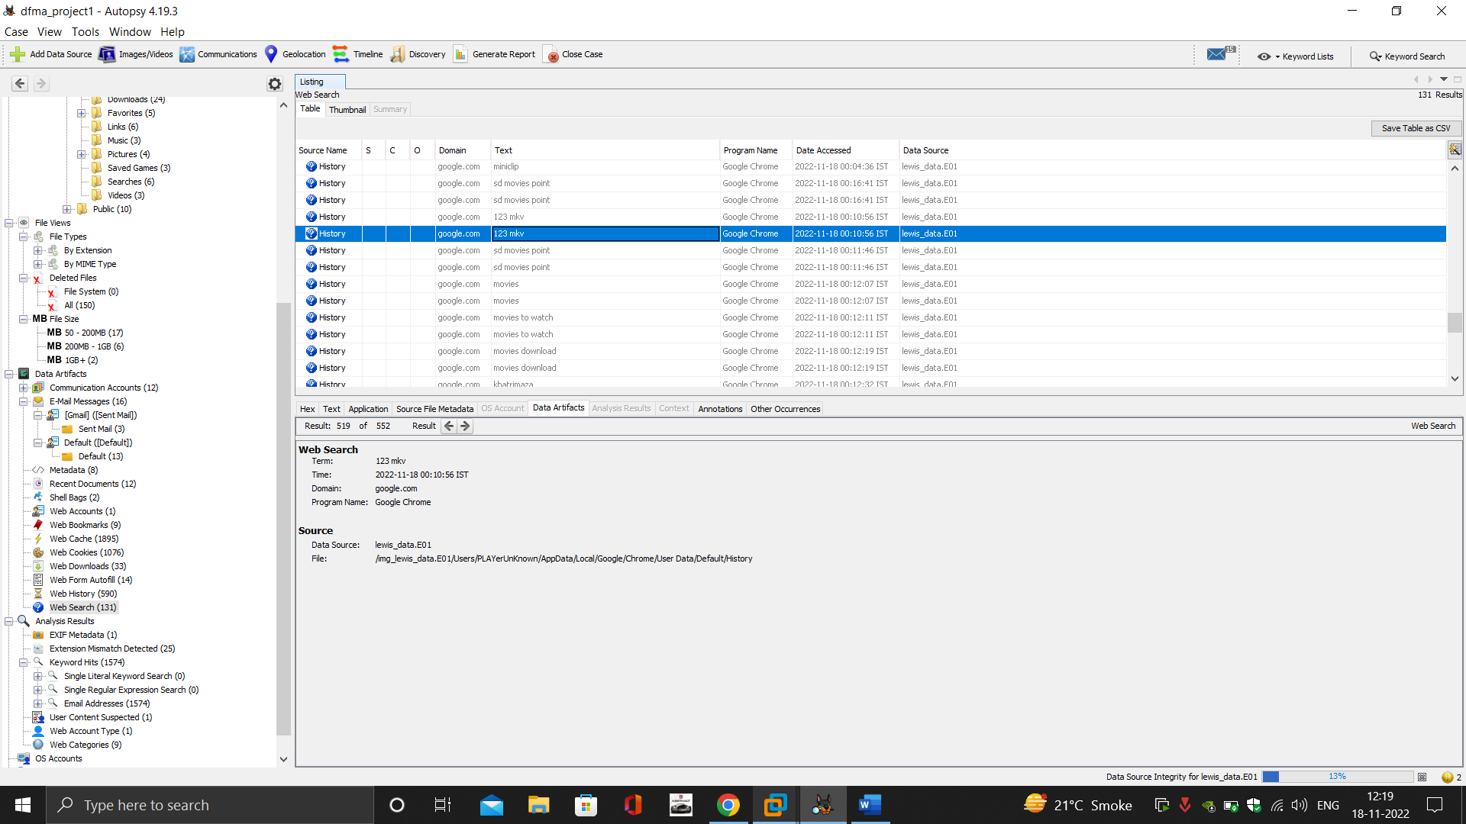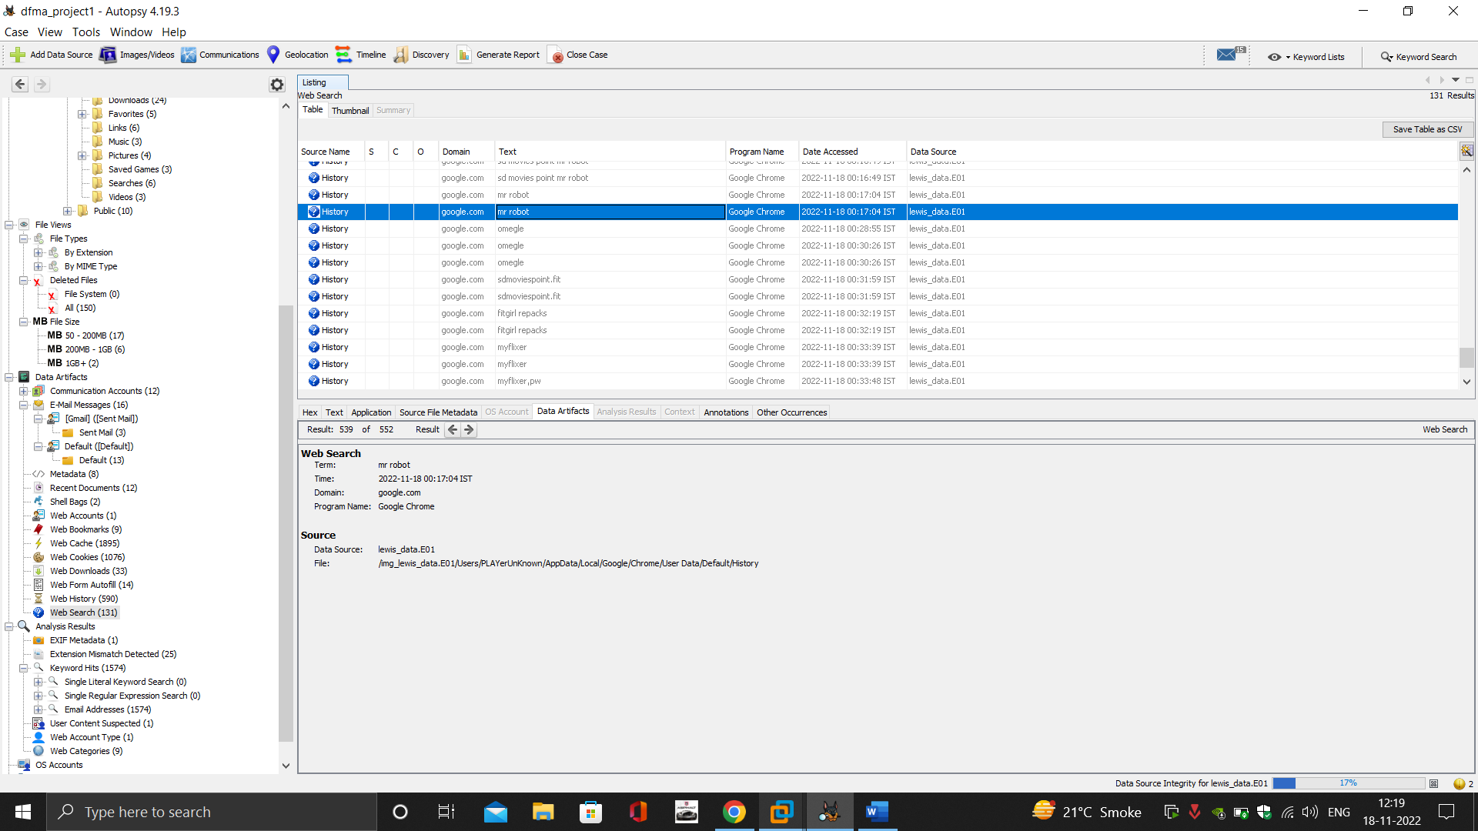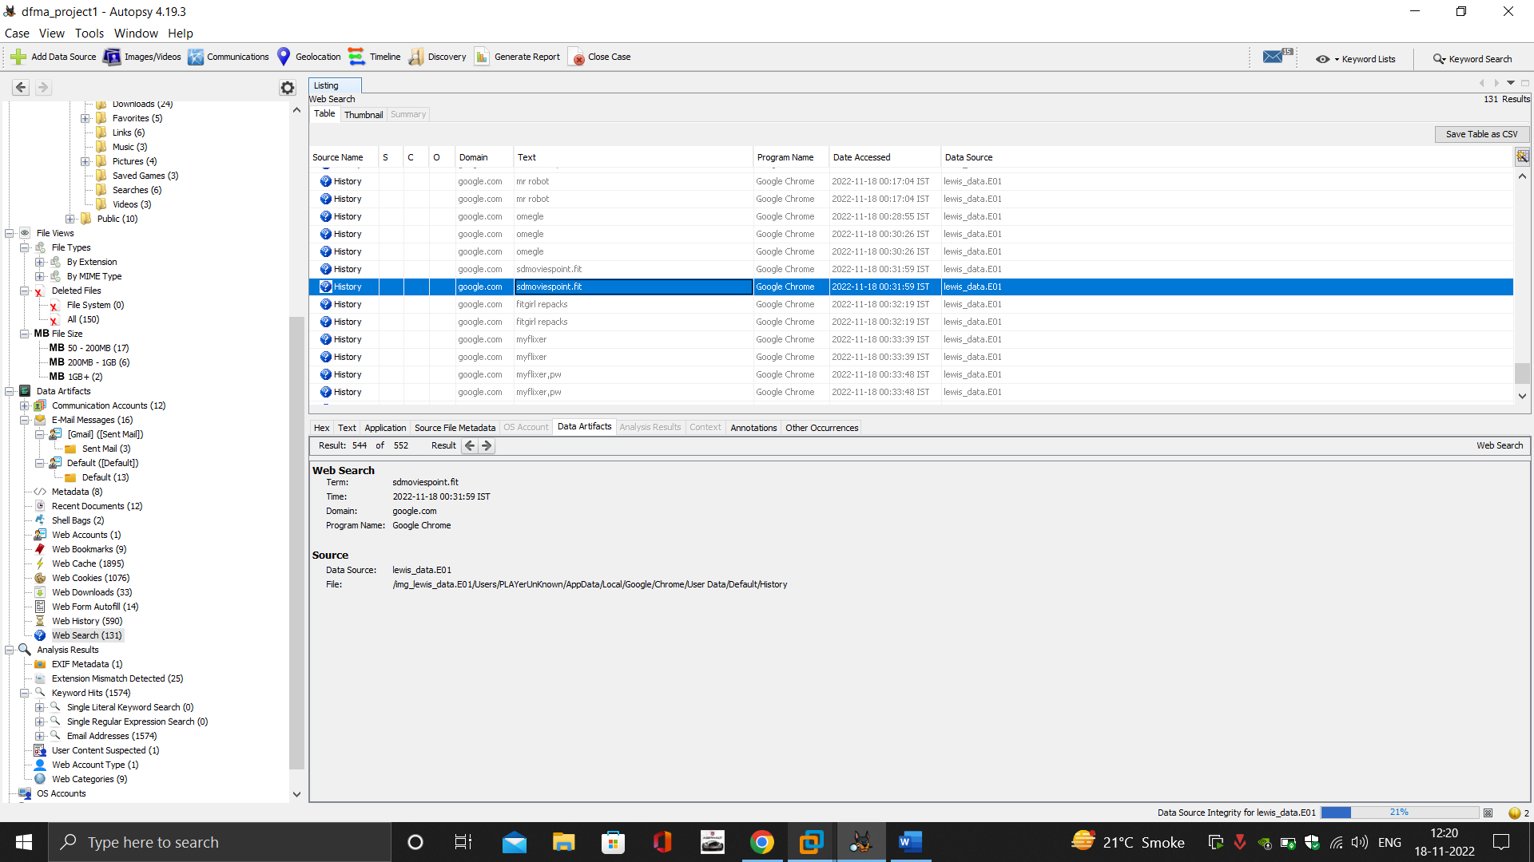

* Bookmarks

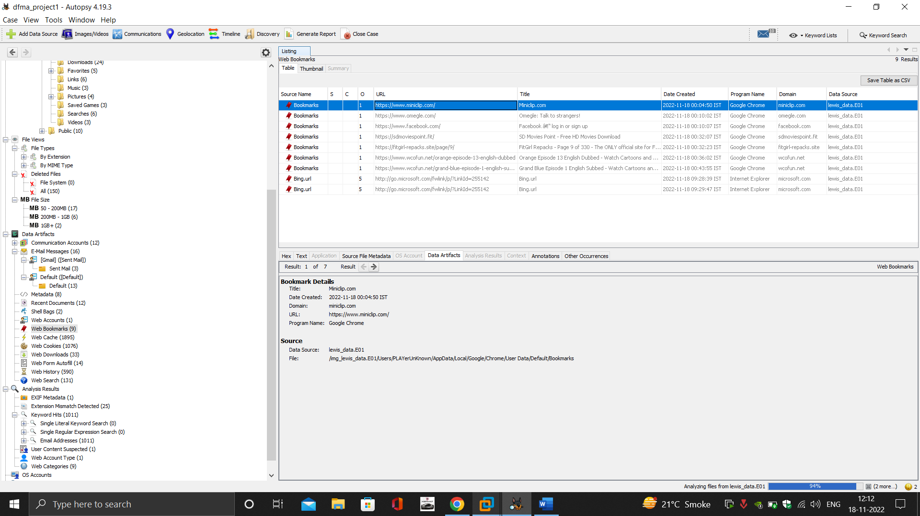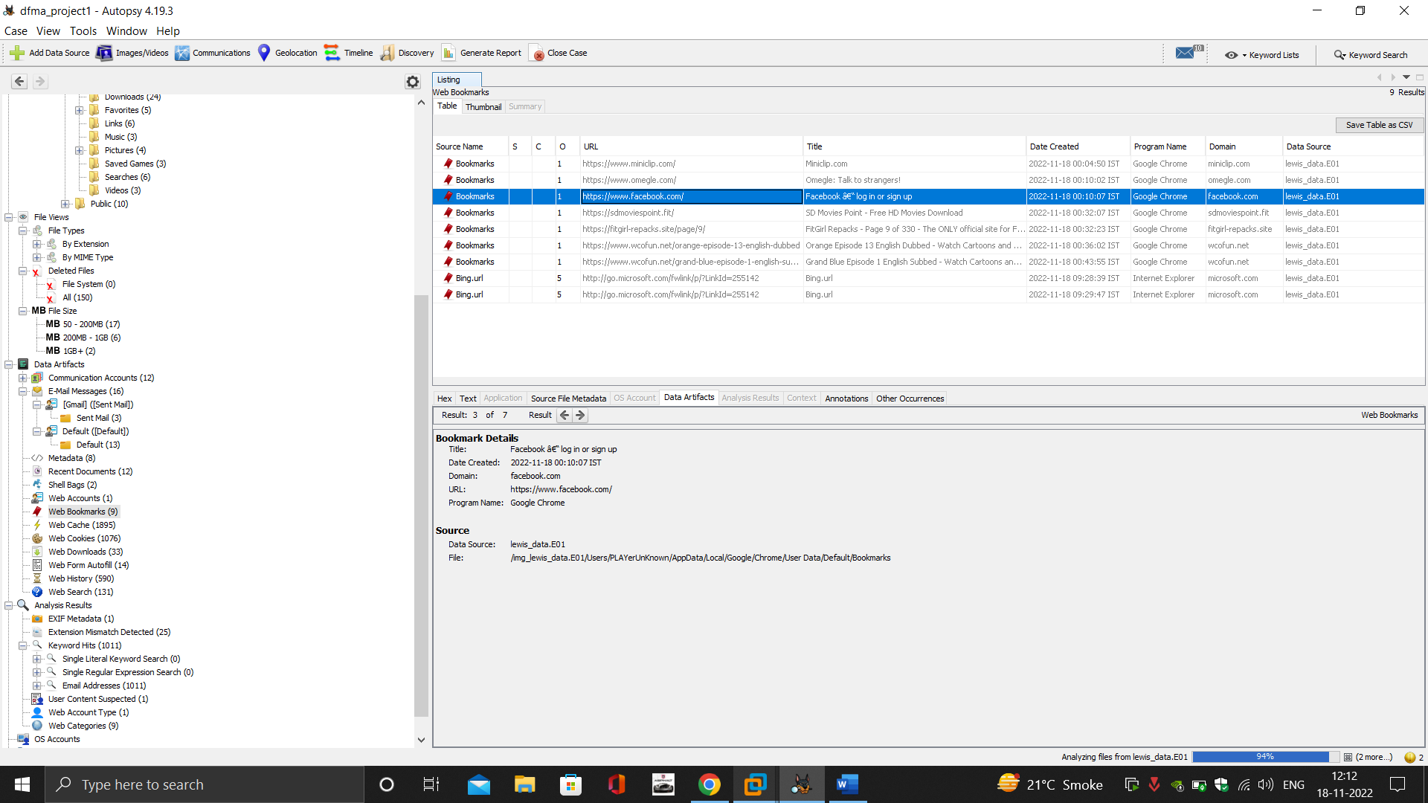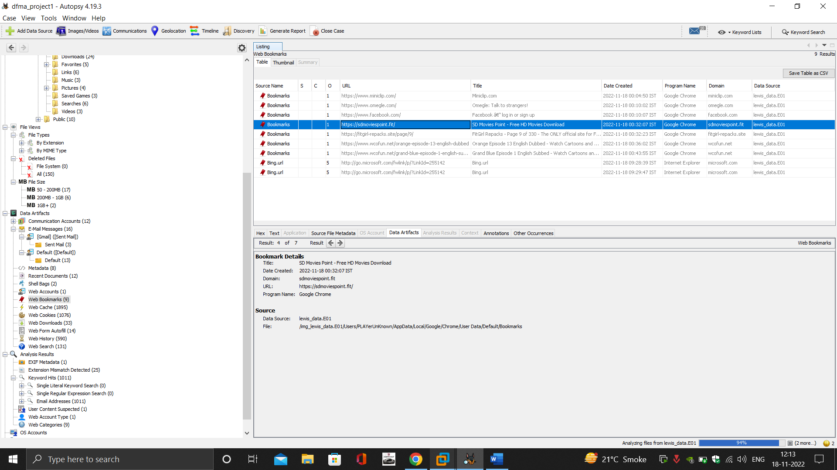

* Downloads



1. General emails with chat with friends

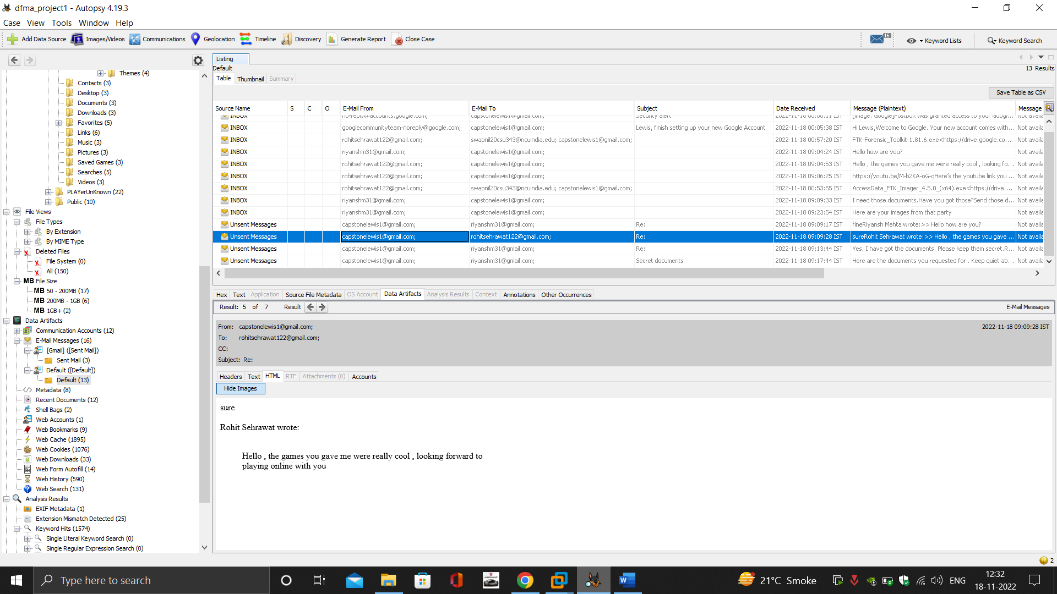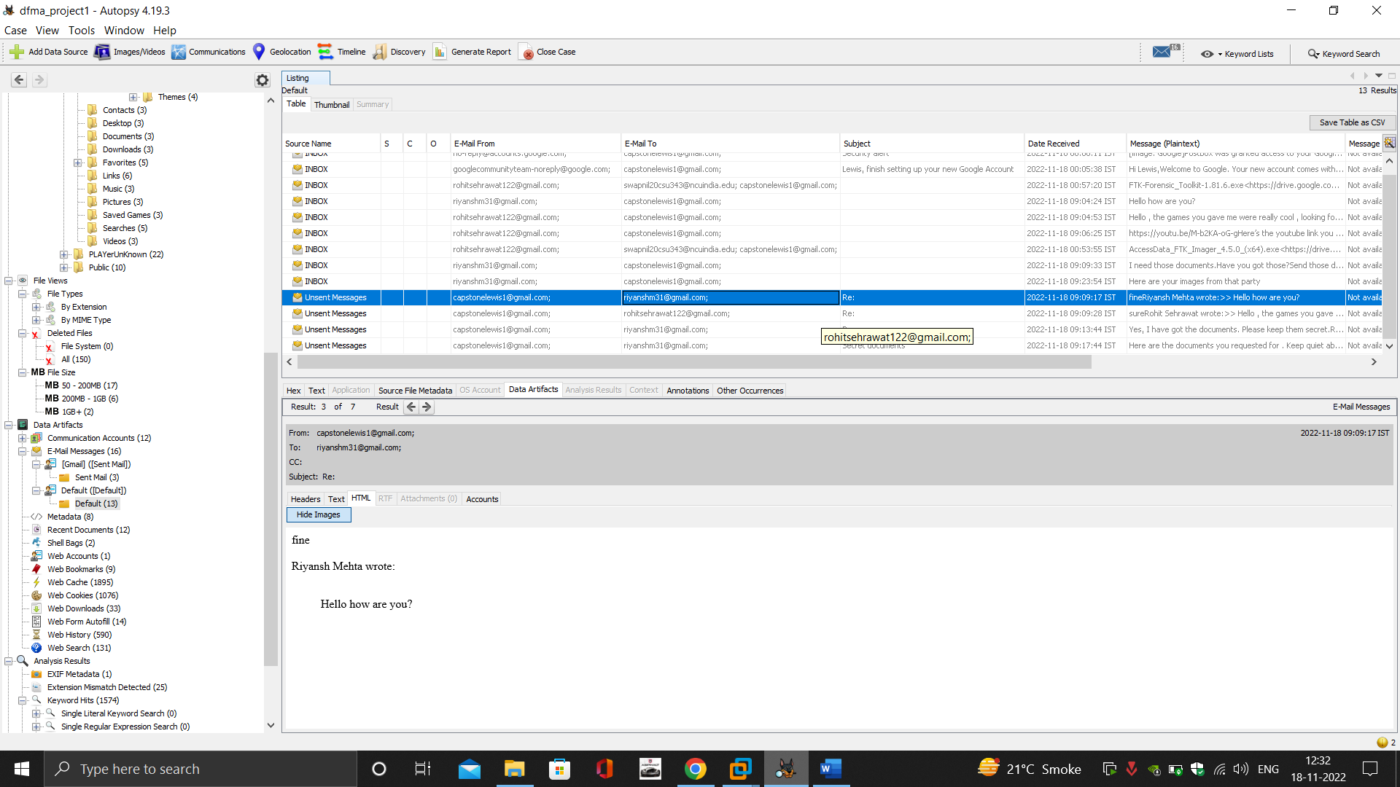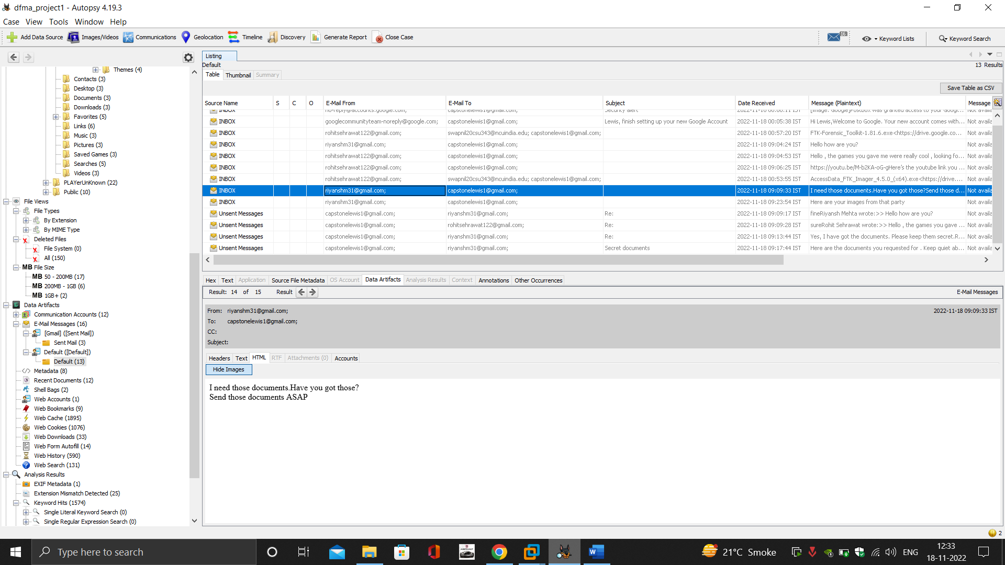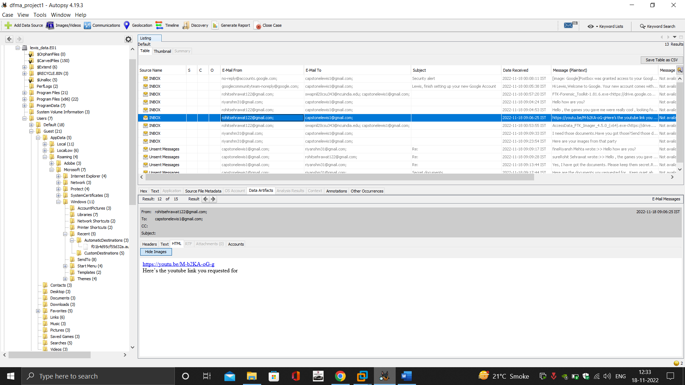

1. Sending private data to shady person

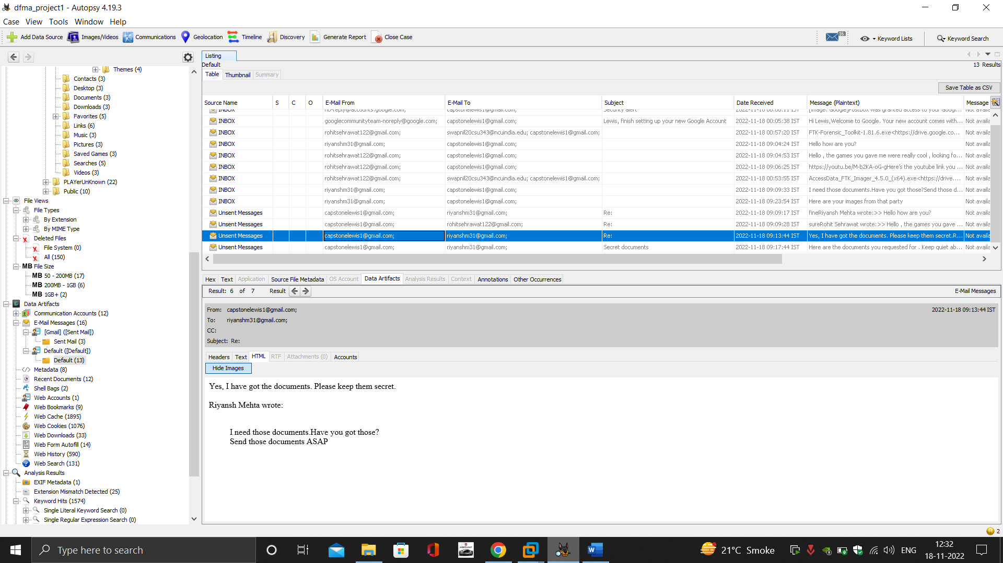

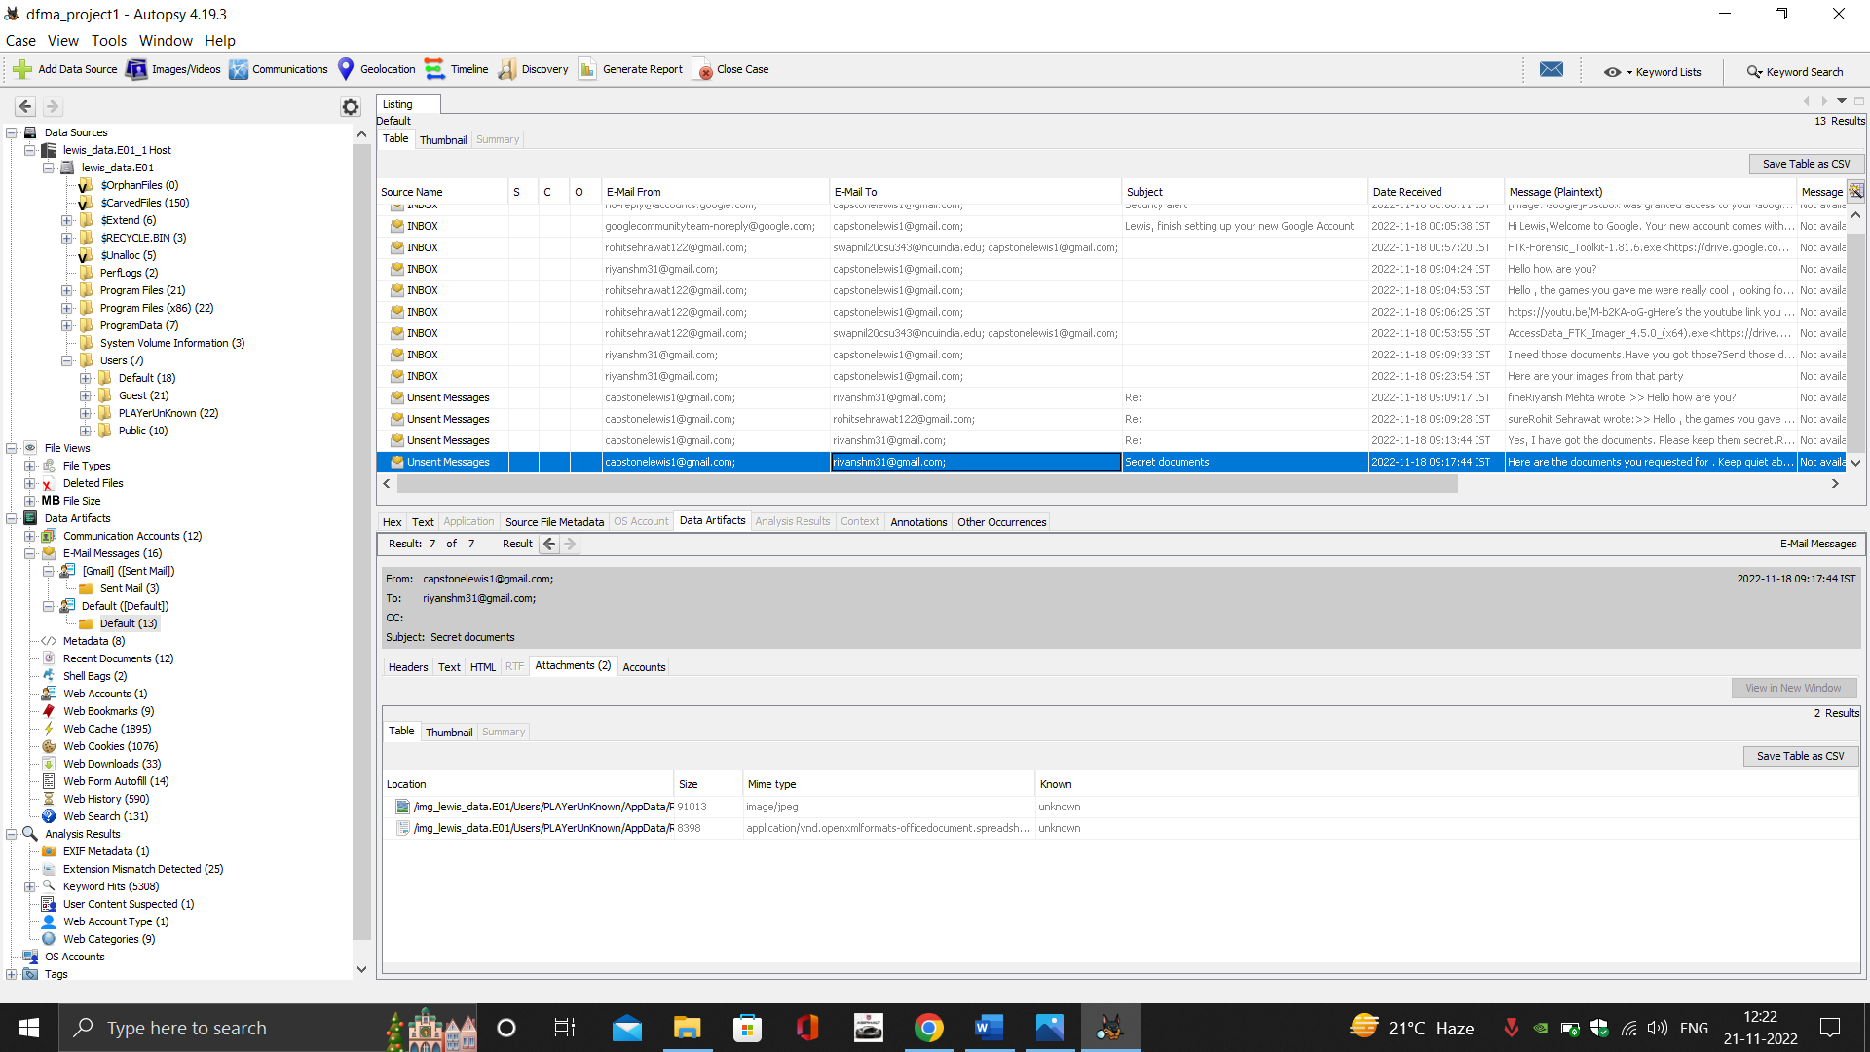

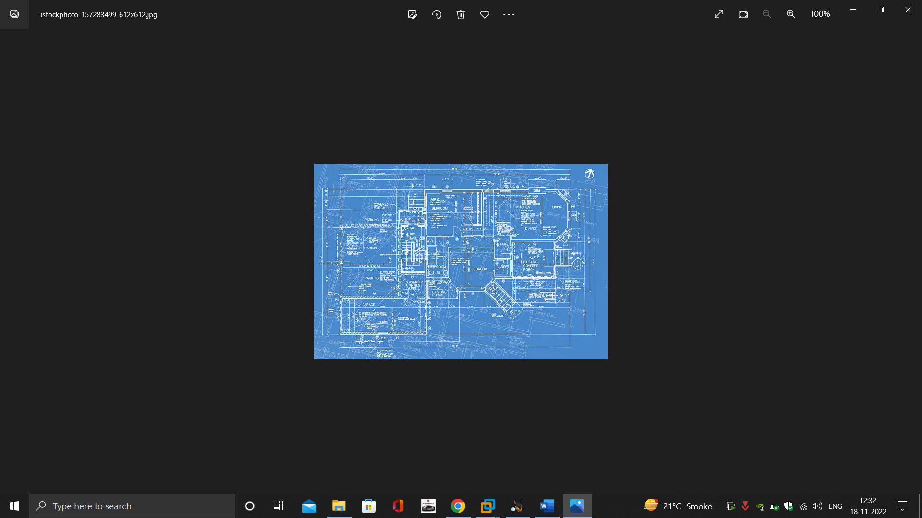

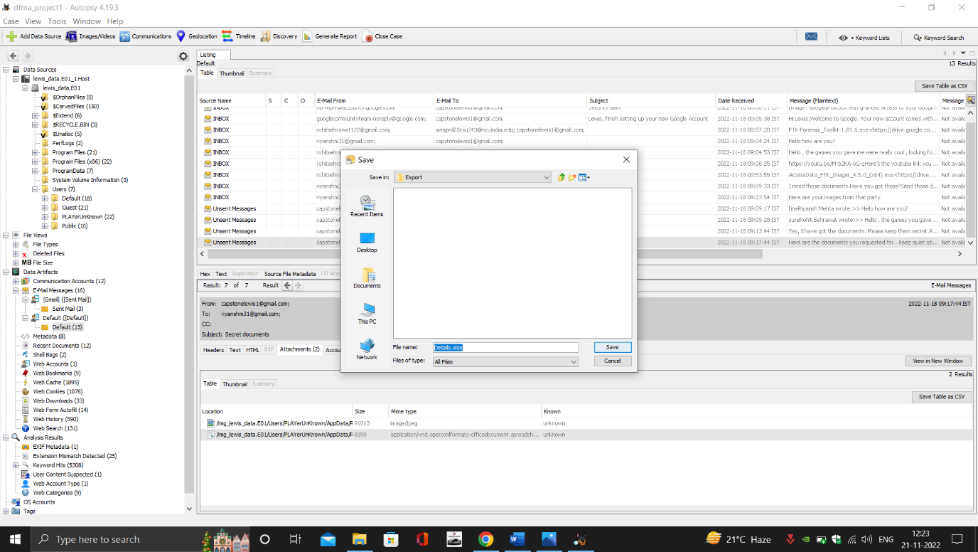

**Conclusion**

We started with passive analysis of the given image of Mr Lewis’ hard drive and found that he was in fact wasting time of the company by logging in to the company pc with his own accounts, also he was browsing a lot of sites repeatedly which were against company policies. He would visit the sites and stay there for a long time and would download movies from shady sites and would play games online. There was hard proof of chats on mails and sending and receiving of links and files from those mails. Also he would use a personal unauthorized usb for transferring data.

In addition to all this we also found evidence of him selling data of company employees to shady person with blueprints of the office which could be used in a lot of wrong ways.

So from all the collected evidence we can conclude that Mr Lewis is wasting a lot of company money and resources also, he is selling company secrets , which makes the management’s suspicion true and they should immediately take action against this employee.

**Challenges Faced:**

1. The size of the images being created were too large for pen drives, so we had to improvise and adapt to finally get the images.
2. The formats of the evidence were different, and we had to use different softwares to finally get our desired results
3. Since some of files were deleted regularly by the user, we weren’t able to get information from previously deleted softwares.

**References:**

- (1) - Information sourced from https://en.wikipedia.org/wiki/Gmail

- (2) - Information sourced from https://en.wikipedia.org/wiki/Forensic_Toolkit

- (3) - Information sourced from https://en.wikipedia.org/wiki/Windows_Registry

- (4) - Information sourced from https://freewareonline.altervista.org/wiki/index.php/USBDeview

- (5) - Information sourced from https://en.wikipedia.org/wiki/Autopsy